Trivy Scan
a) For Kubernetes Cluster:
- Get report summary (skipped image scan as it takes a lot of time to download all images)
trivy k8s --report summary --skip-images
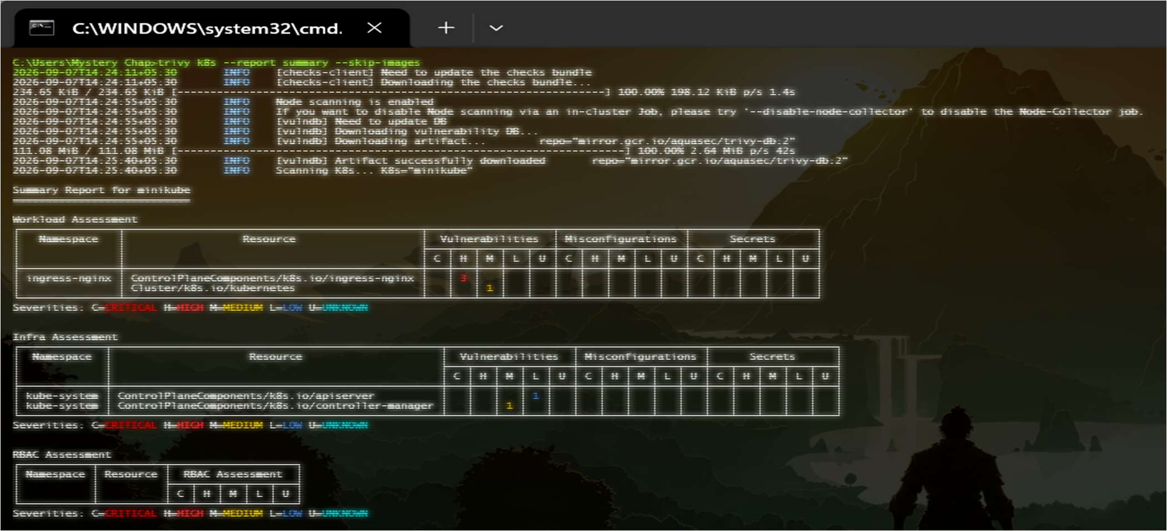

- Scan particular namespace only
trivy k8s --include-namespaces kube-system --report summary --skip-images
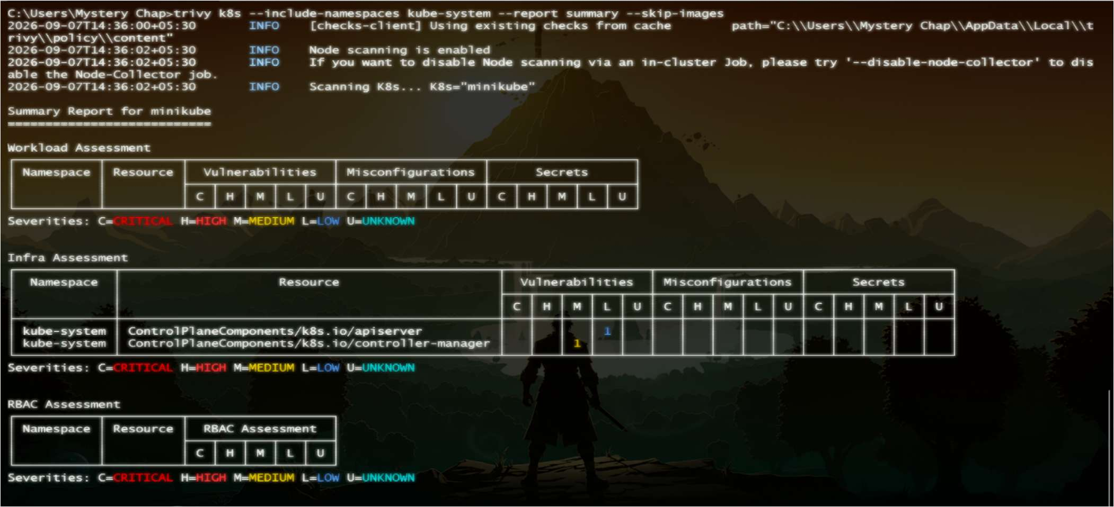

- Scan only for vulnerability (other scanners are secret and misconfiguration)
trivy k8s --scanners vuln --report all --skip-images
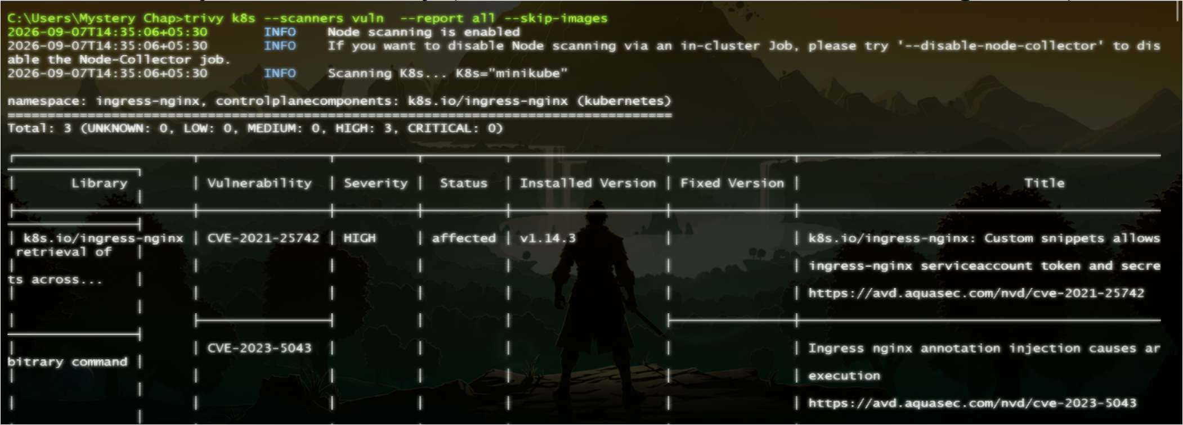

- Exclude or include particular kube-objects
trivy k8s --report summary --exclude-kinds node,pod --skip-images
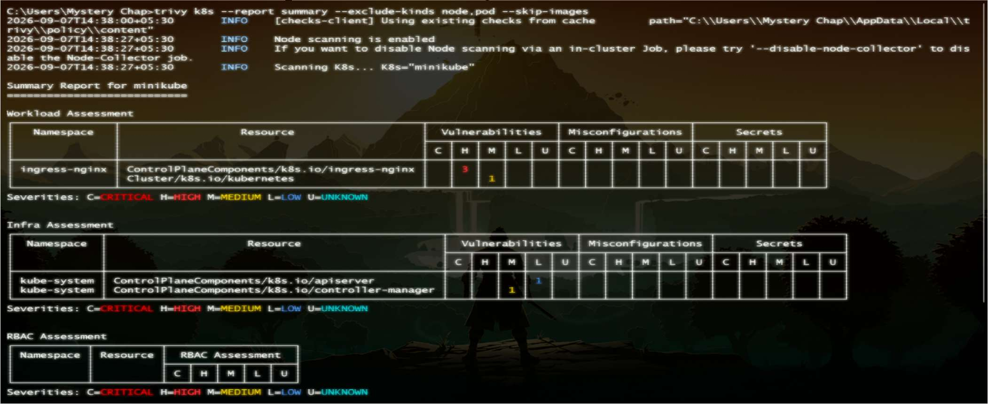

- Filter by severity
trivy k8s --report summary --skip-images --severity HIGH
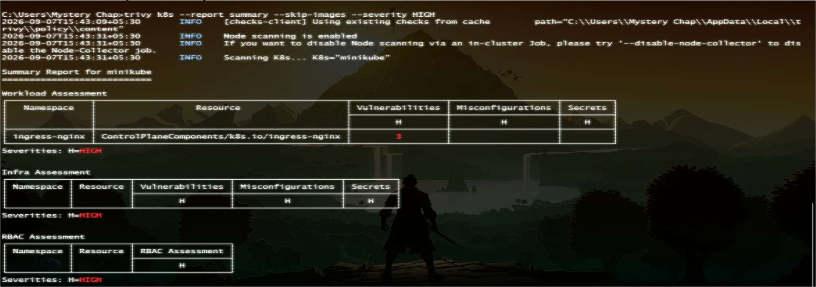

- Check for any misconfigurations (lack of general security practice in manifest)
trivy config .
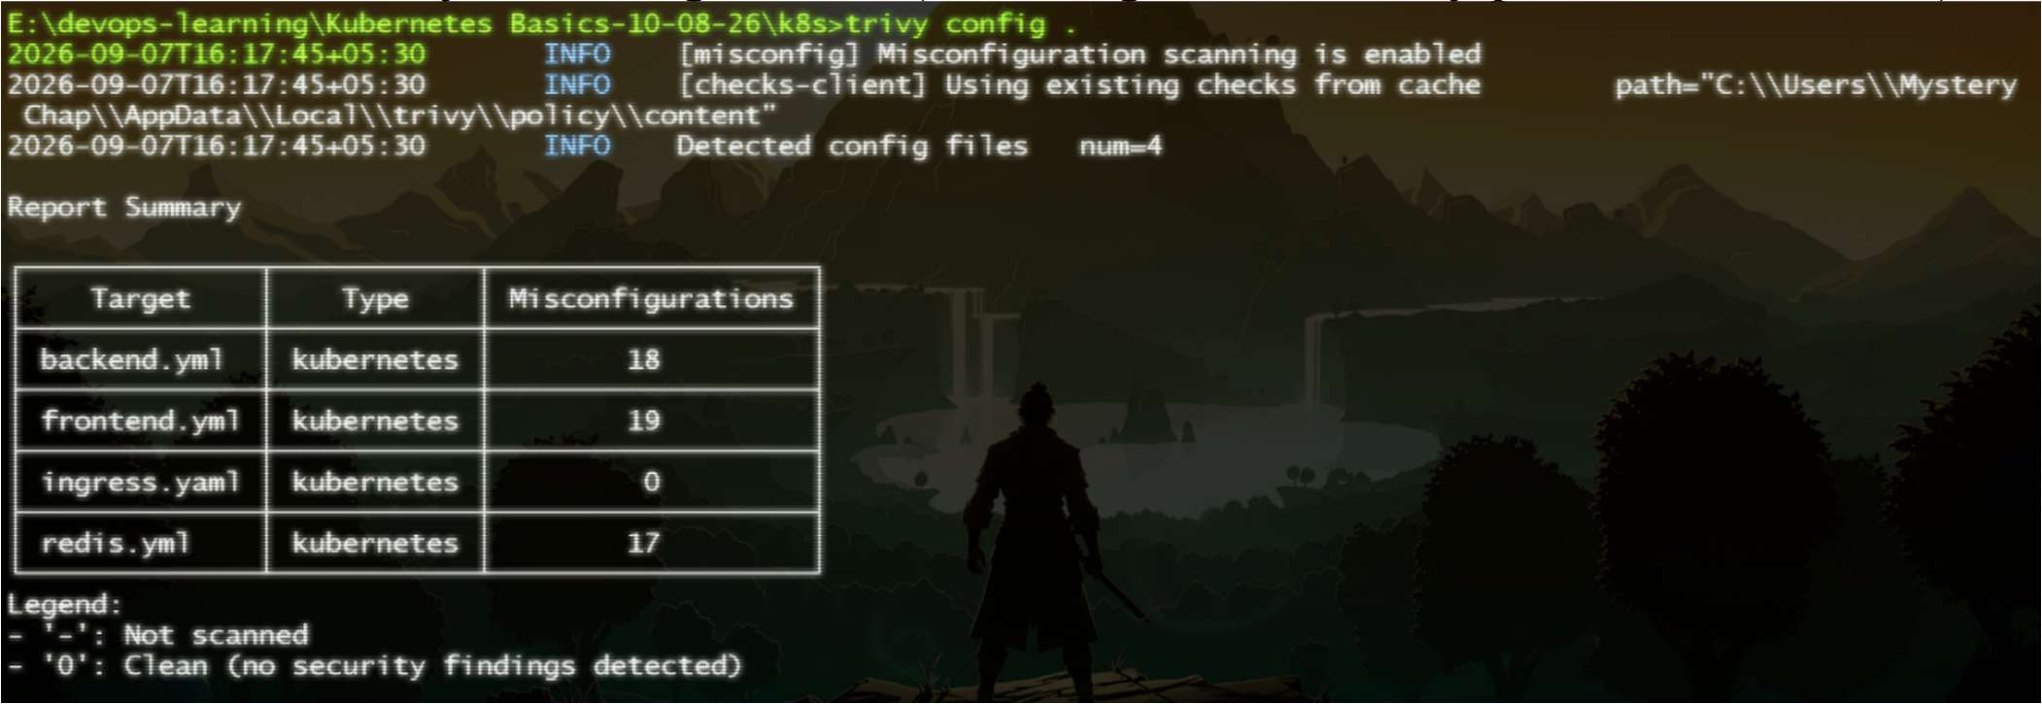

b) For IaC – Terraform:
- Check for any misconfigurations (lack of general security practice in manifest)
trivy config ./
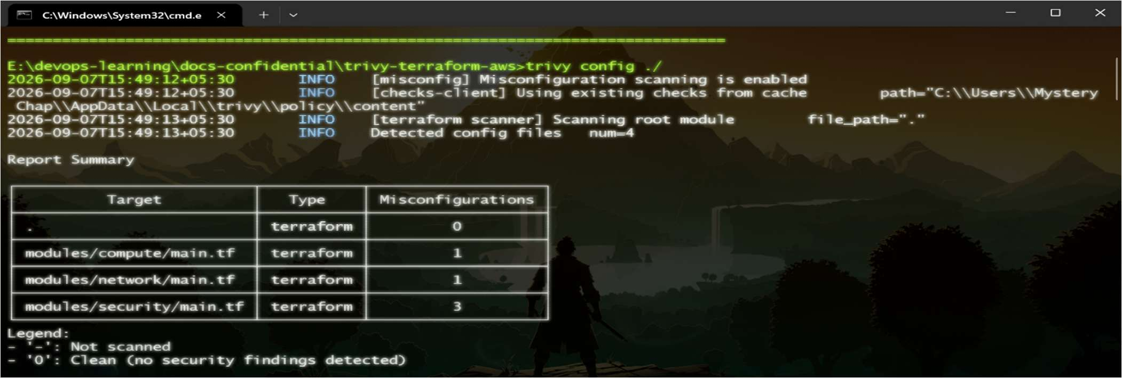

- Store output in a file
trivy config -f json -o scan-result.json .
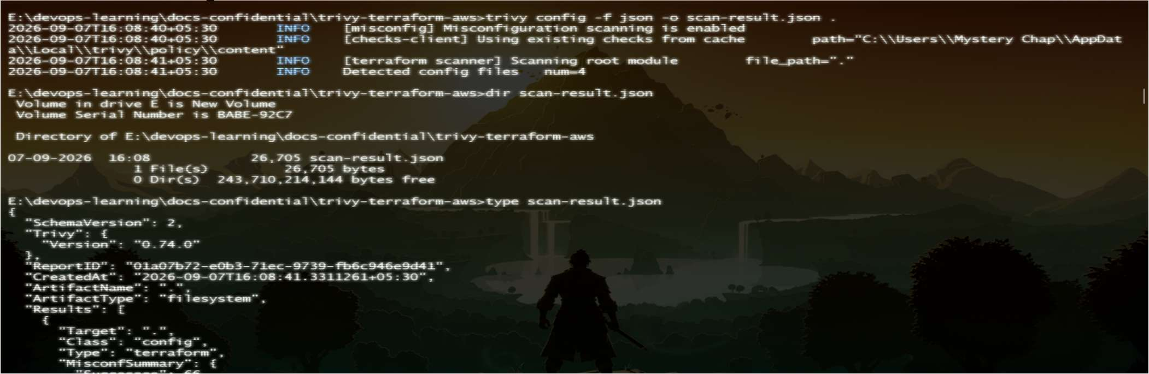

- Filter by severity
trivy config --severity CRITICAL .
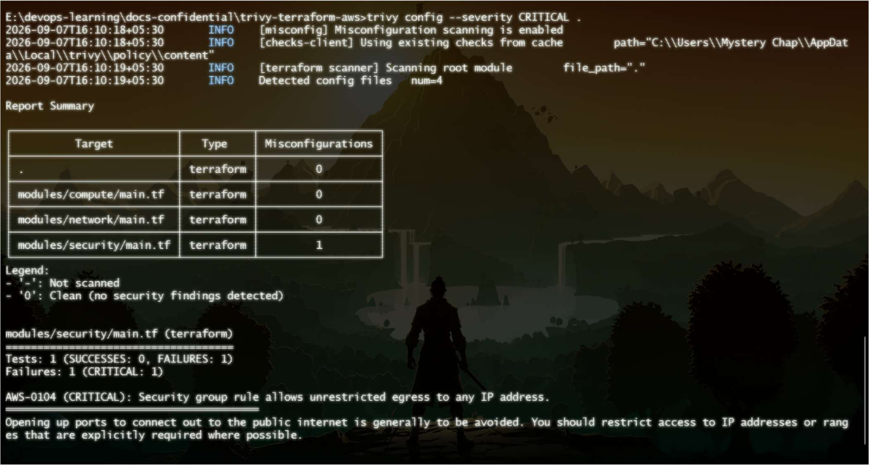

- Feed contents in terraform.tfvars and check for misconfigurations
trivy config --tf-vars terraform.tfvars ./
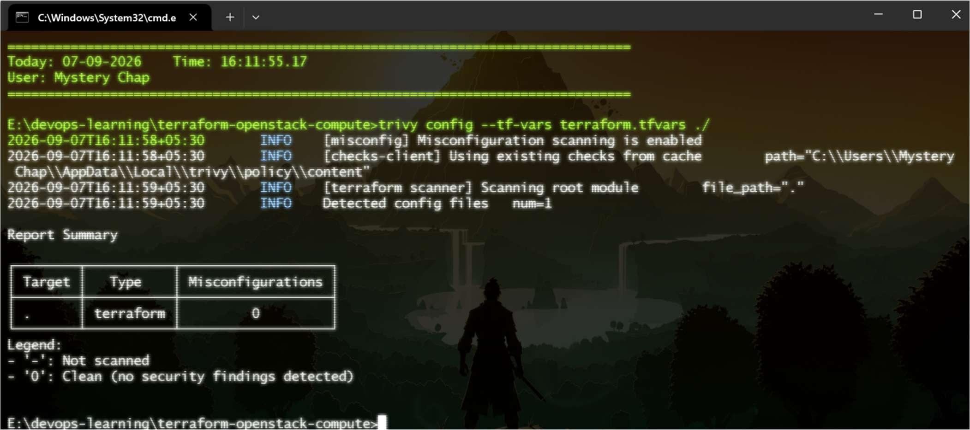

c) OS level Scan:
- Check license of a particular image or OS's library
trivy image --scanners license nginx
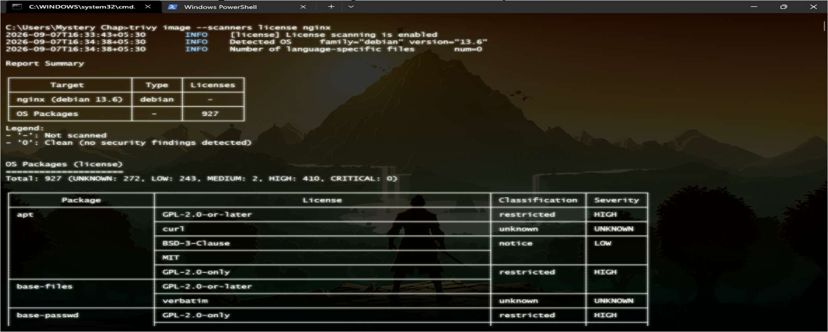

- Scan and get SBOM of a software
trivy image -f cyclonedx -o results.cdx.json nginx
trivy sbom results.cdx.json
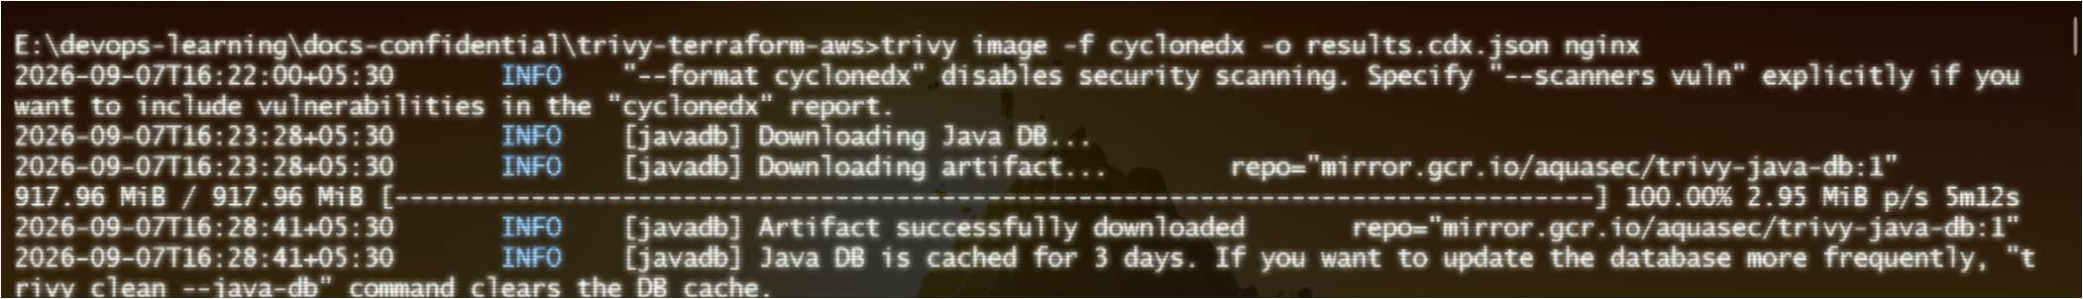
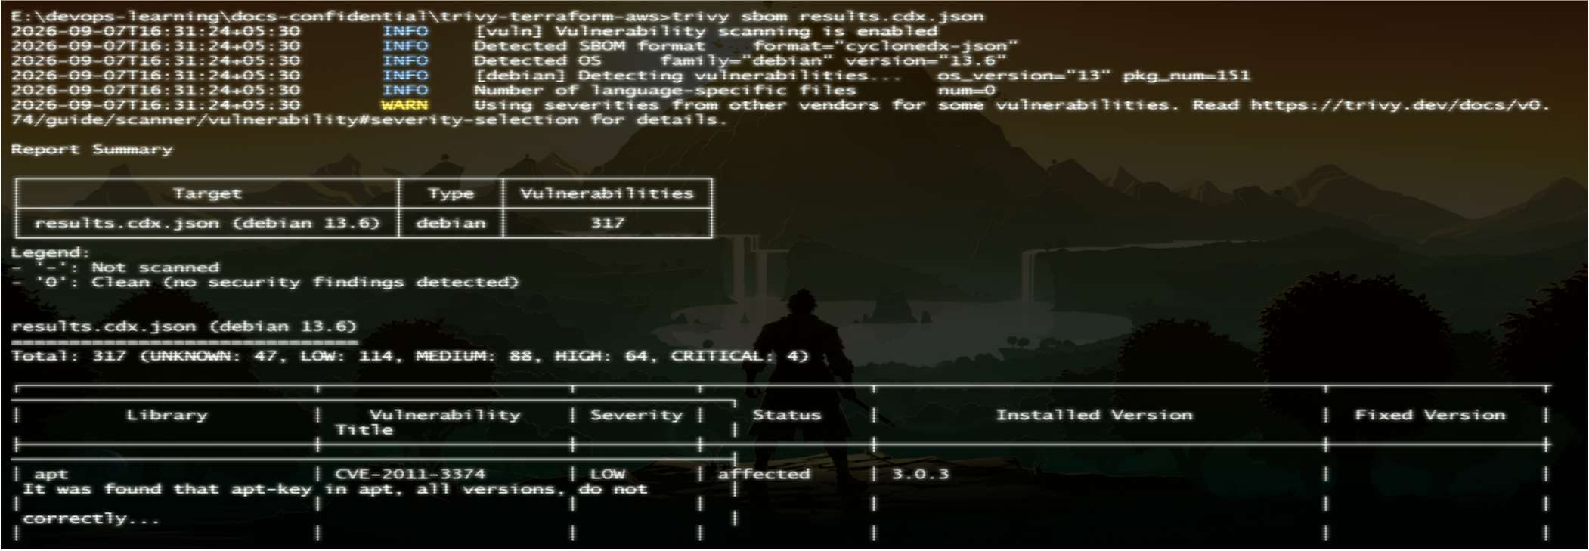

- Write the report to a particular template/format using a .tpl file
trivy image --format template --template "@trivy/contrib/html.tpl" -o report.html nginx
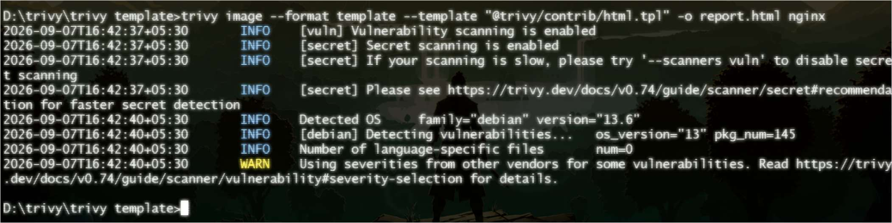
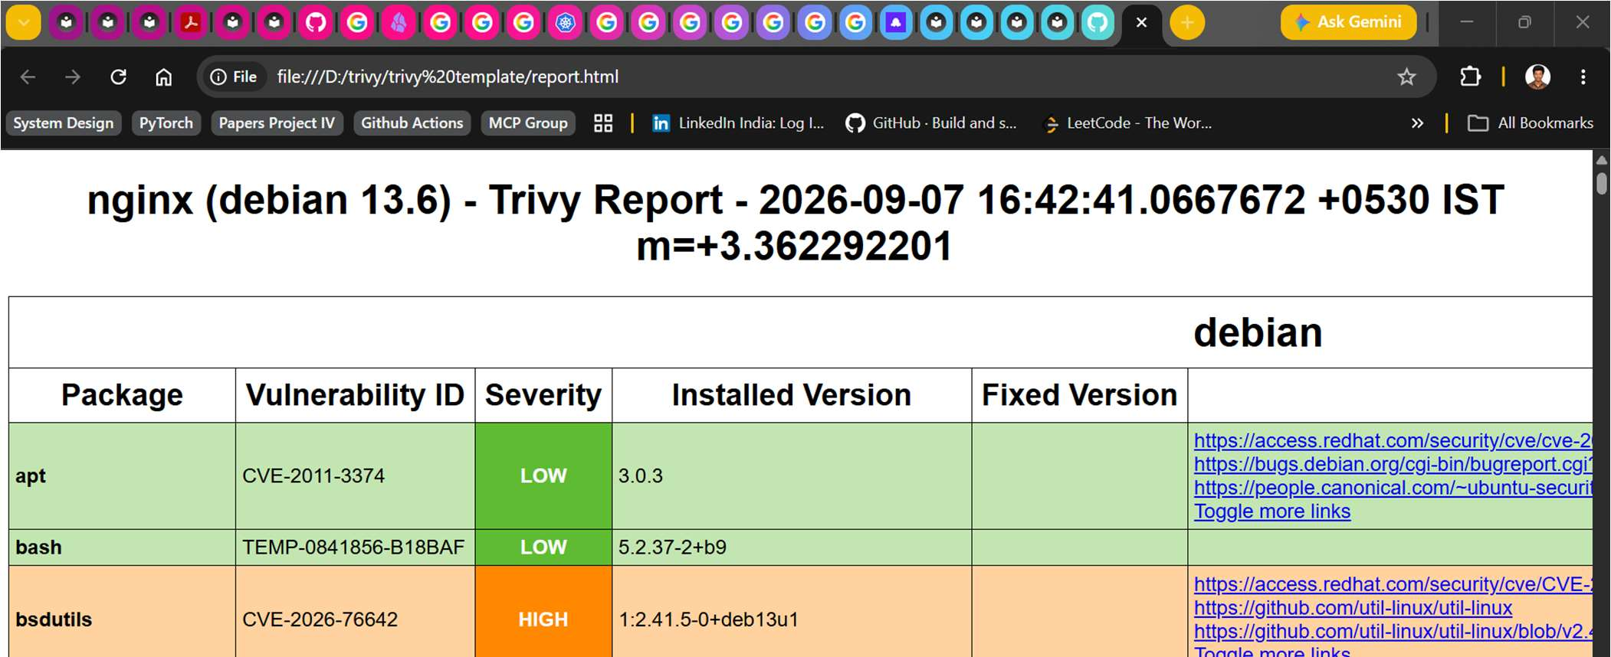

- Scan Your Local Machine's File System
trivy fs --pkg-types os /
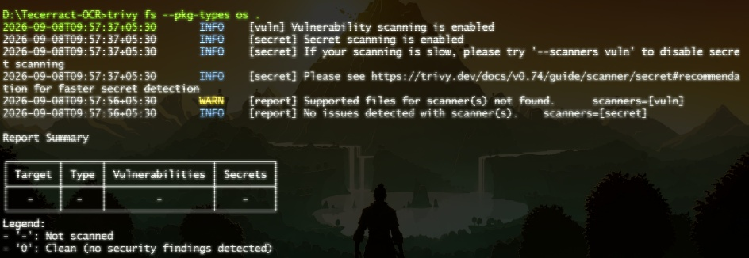
- Scan and Only Show Issues You Can Fix Right Now
trivy image --ignore-unfixed --pkg-types os debian:12-slim
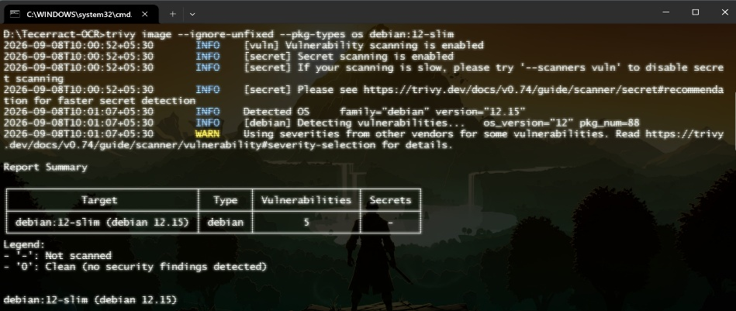
- Scan image based on architecture
trivy image --platform linux/amd64 --pkg-types os debian:12-slim
